Grafana installation

After installing the Prometheus server and node exporter let's install the Grafana for setting up visualization using Grafana dashboard. Here is the official download link of Grafana, choose the correct Grafana binary based on your operating system. For now, I’m going to use ubuntu Linux binary.

- Install the prerequisite packages:
sudo apt-get install -y apt-transport-https software-properties-common wget
- Import the GPG key:
sudo mkdir -p /etc/apt/keyrings/
wget -q -O - https://apt.grafana.com/gpg.key | gpg --dearmor | sudo tee /etc/apt/keyrings/grafana.gpg > /dev/null
- To add a repository for stable releases, run the following command:
echo "deb [signed-by=/etc/apt/keyrings/grafana.gpg] https://apt.grafana.com stable main" | sudo tee -a /etc/apt/sources.list.d/grafana.list
- Run the following command to update the list of available packages:
# Updates the list of available packages
sudo apt-get update
- To install Grafana OSS, run the following command:
# Installs the latest OSS release:
sudo apt-get install grafana
- Start the Grafana server
sudo systemctl start grafana-server

Next, verify that Grafana is running by checking the service’s status:
sudo systemctl status grafana-server
You will receive output similar to this:
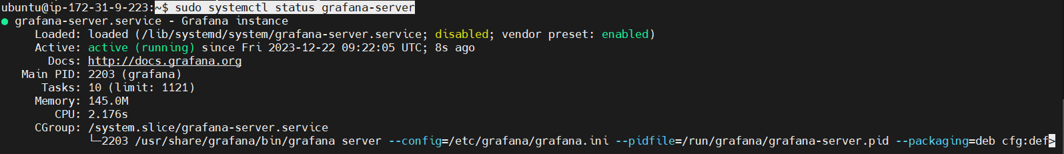
This output contains information about Grafana’s process, including its status, Main Process Identifier (PID), and more. active (running) shows that the process is running correctly.
Lastly, enable the service to automatically start Grafana on boot:
$ sudo systemctl enable grafana-server
You will receive the following output:
This confirms that systemd has created the necessary symbolic links to autostart Grafana.
Grafana is now installed and ready for use.
Access the Grafana Dashboard using
http://3.109.207.118:3000/login
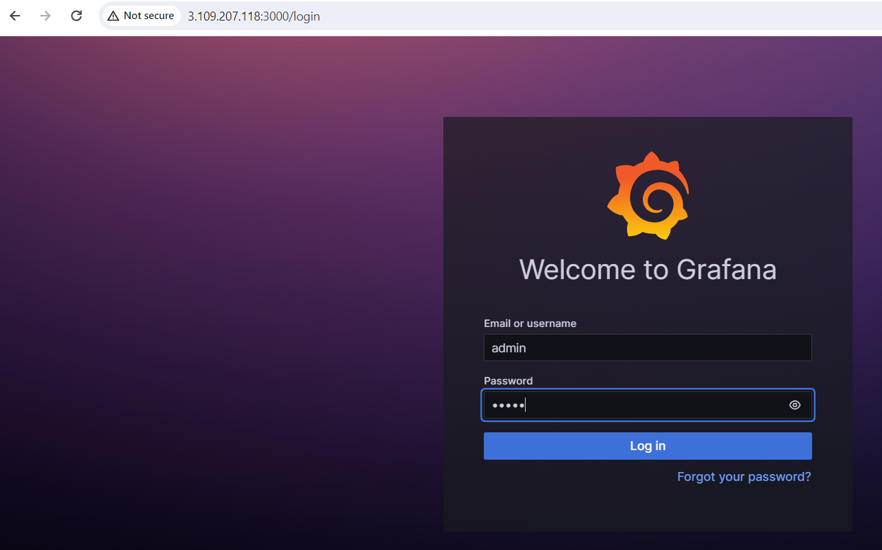
The default login Username: Password for accessing the Grafana dashboard is admin: admin
Change the default admin password after the login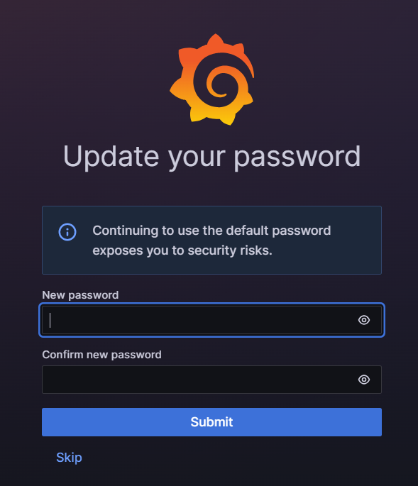

Setting up the Grafana Dashboard
The next step after installing the Grafana Server would be to set up the Grafana Dashboard. Till now, we have installed the Prometheus Server, Node Exporter as well as Grafana Server but there is a connection between Prometheus and Grafana.
As I mentioned earlier Grafana is an analytics and visualization dashboard, Grafana does not store data, but instead it relies on Datasource connection towards the Prometheus server because Prometheus server is responsible for scraping and storing the data.

Let's create a Prometheus Datasource inside Grafana Dashboard
Goto your Grafana Dashboard and click on home/connections ->Data Sources

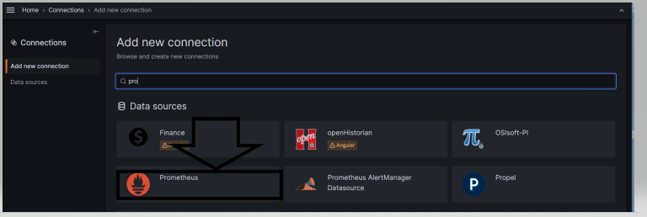

Enter the hostname or IP address of the prometheus server
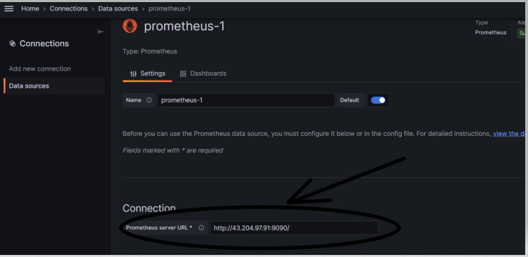
Create Dashboard
Go to Import and enter the board ID .e.g. 2747
grafana Dashboard id : 10180
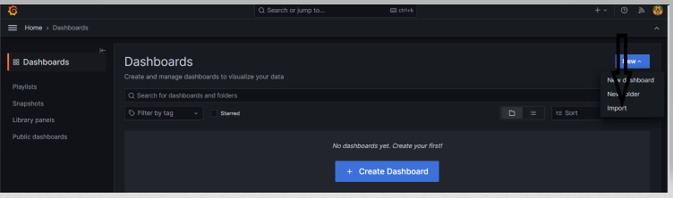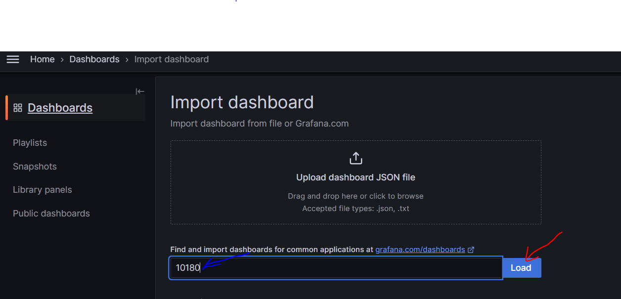

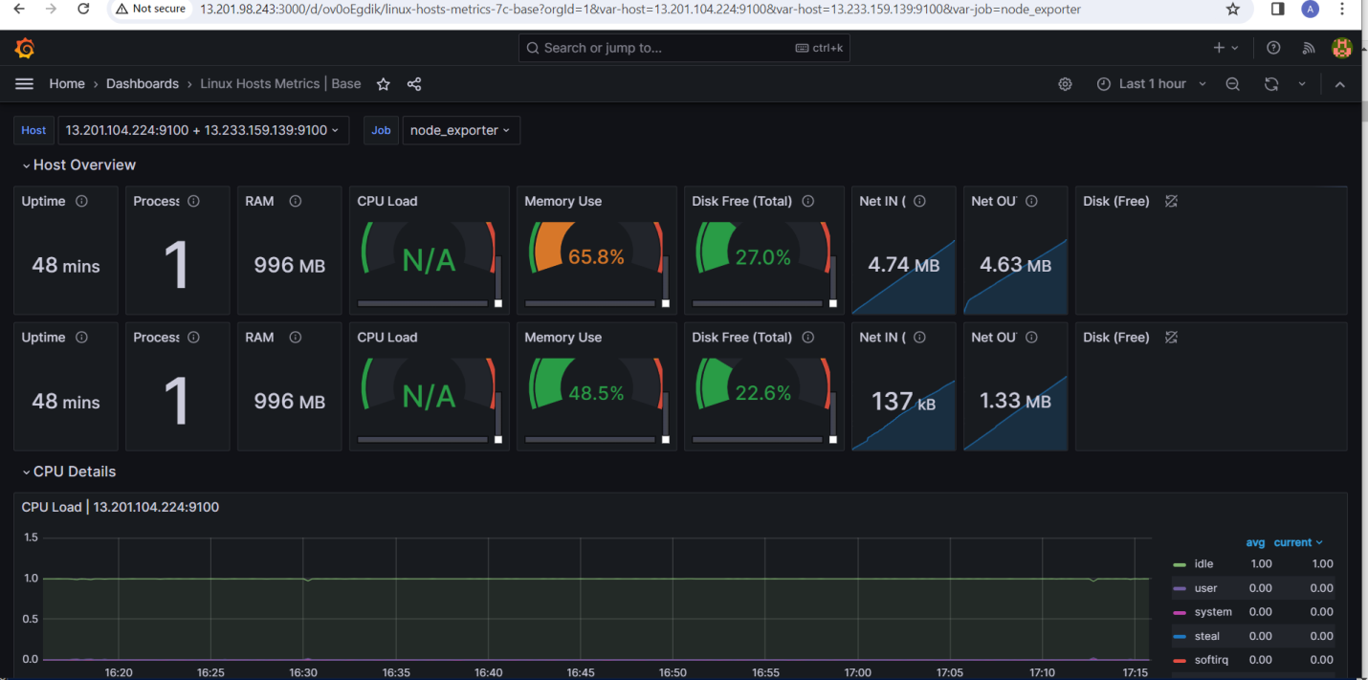

Advantages of Prometheus
Now I have talked about how to install and use Prometheus along with Grafana, let's see what are the advantages of using Prometheus in the landscape of DevOps and SREs –

- Prometheus is a very independent framework that does not impact your existing cloud or in-premise infrastructure.
- It can be customized to suit your infrastructure needs
- To use Prometheus and Node exporter a developer does not have to install all the node exporters available in the market. A Developer can only install the required node exporter and to avoid extra overhead on the hardware resources
- Prometheus node exporter can be customized to suit your infrastructure need, if you do not find a suitable node exporter in the library then Prometheus allows you to build a custom node exporter.
- Prometheus comes along with PromQL and TSDB which make it a more powerful tool for debugging troubleshooting.
- Prometheus has a built in database and you do not have to install the database separately.
- The pull mechanism of Prometheus is very flexible, and it allows you to schedule variable scrappers at different intervals.
- Also, Prometheus is being open-source, it has a wide variety of community support available for developers.

6. Advantages of Grafana
- If you compare Grafana with traditional tools Zabbix and LibreNMS then Grafana allows you to create multiple datasource whereas Zabbix and LibreNMS allow you only to create a single Datasource.
- In the Grafana dashboard you can customize various panels based on your requirement, also you can have integration with multiple data sources in the same Dashboard which is by far the biggest merit of using Grafana.
- In Grafana open-source community you can share your dashboard settings with others, and similarly, you can use other's dashboards by searching it on Grafana Community, so you do not have to re-invent the wheel again.
- Grafana dashboard's user experience is very pleasing and also it allows a developer to put PNG images on the dashboard to make it more appealing.
- Grafana developer community is building a lot of features and various datasource support which makes Grafana more adaptable for various infrastructure monitoring needs.

